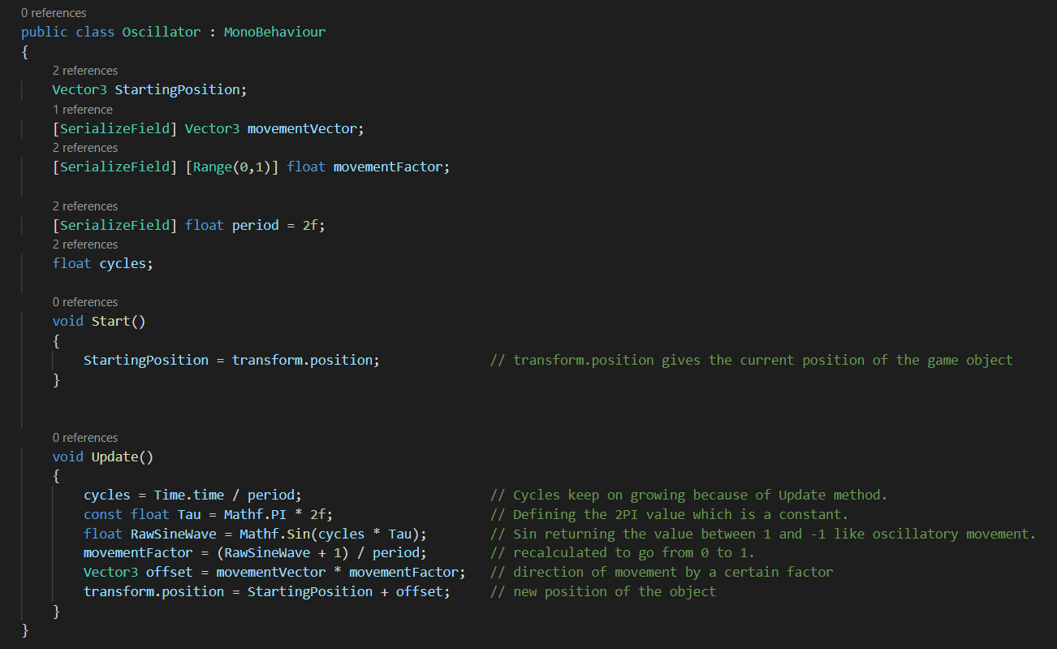Mathf.Sin for Oscillatory Movement

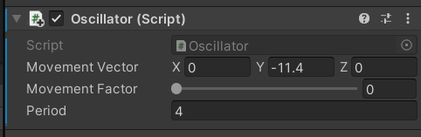

Changing the Movement Vector for desired direction.

Changing the time period for speed of oscillation.